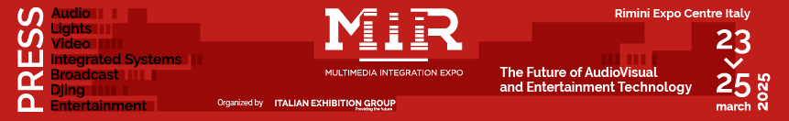

press release no.7
(English translation)

MIR 2025 LAYOUT
Rimini, 23-25 March 2025 – The eighth edition of MIR – Multimedia Integration Expo will occupy eight halls in Rimini Expo Centre, accessible from the South Hall (South Entrance, Via Emilia, 155 – Rimini).

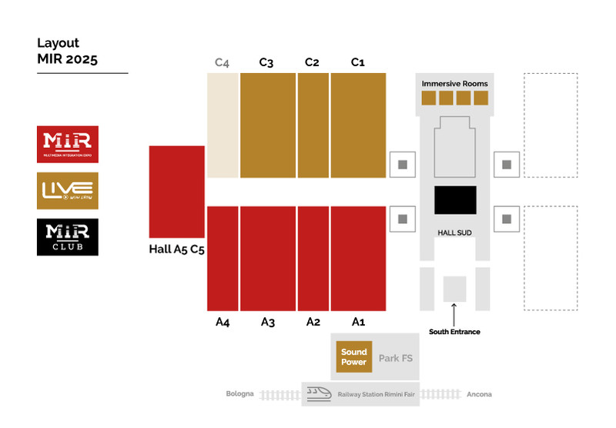

The South Hall houses the MIR Club area, a space dedicated to makers and enthusiasts in the DJ and Music Entertainment world. The first floor hosts the Immersive Sound demo rooms.
MIR takes places in Halls A1, A2, A3, A4, and A5 (C5), showcasing solutions designed by leading companies in the fields of audio, video, lighting, education, retail, museum, hospitality, live events, and system integration. Among this year's highlights, the debut of the new Corporate Communication Pavilion in Hall A4, an exhibition space where you can test and evaluate technologies shaping the future of work environments.
The LIVE YOU PLAY format is set up in Halls C3, C2, and C1, featuring the renowned stages where all audio, video, and lighting technologies are showcased and tested, fully operational and ready for demonstration.
Finally, Sound Power will be featured in the FS Park, an outdoor area with high sound pressure allowing visitors to test the performance of some of the world's most advanced audio systems in real-life conditions.

ABOUT MIR 2025
Date: 23/25 March 2025; event type: international expo; organizer: Italian Exhibition Group S.p.A.; recurrence: annual; edition: 9th; open to: general public and professional operators; info: www.mirtechexpo.com

ABOUT MIR 2025
Date: 23/25 March 2025; event type: international expo; organizer: Italian Exhibition Group S.p.A.; recurrence: annual; edition: 9th; open to: general public and professional operators; info: www.mirtechexpo.com

PRESS CONTACT ITALIAN EXHIBITION GROUP
head of corporate communication & media relation: Elisabetta Vitali
press office manager: Marco Forcellini, Pier Francesco Bellini | press office coordinator: Luca Paganin | international press office coordinator: Silvia Giorgi | press office specialist: Mirko Malgieri; Nicoletta Evangelisti | media@iegexpo.it

MEDIA AGENCY MIR
Naper Multimedia| Zoe Perna | T. +39 02 97699600 | zoe.perna@napermultimedia.it | staff@napermultimedia.it

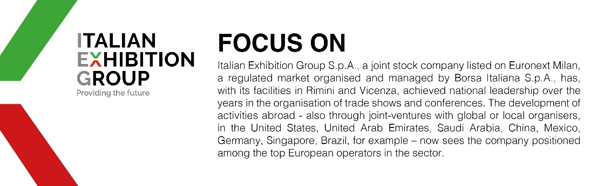

This press release contains forecast elements and estimates that reflect the management´s current opinions (´forward-looking statements´), particularly regarding future management performance, realization of investments, cash flow trends and the evolution of the financial structure. For their very nature, forward-looking statements have a component of risk and uncertainty, as they depend on the occurrence of future events. The effective results may differ (even significantly) from those announced, due to numerous factors, including, only by way of example: food service market and tourist flow trends in Italy, gold and jewellery market trends, green economy market trends; the evolution of raw material prices; general macroeconomic conditions; geopolitical factors and evolutions in the legislative framework. Moreover, the information contained in this release, does not claim to be complete, and has not been verified by independent third parties. Forecasts, estimates and objectives contained herein are based on the information available to the Company as at the date of this release.

